VENDOR TEMPORARY FOOD LICENSE APPLICATION
The VENDOR of each temporary food event must complete this application with remittance of $75.00 (non profit events $25) by CERTIFIED CHECK, MONEY ORDER or CREDIT CARD only (no cash or personal checks) payable to the City of Hartford and must be filed *(15) days prior to the opening event. This application and $75.00 (nonprofit $25) must be submitted to the Department of Health and Human Services, Environmental Health Division, 131 Coventry Street, Hartford, CT 06112.

*In addition applications received between 5-15 days prior to the event will be charged $125. Applications received less than 5 days prior to the day of the event will be levied $150. This applies to all applicants including Not-For-Profit Organizations.
*This application is not a license. Temporary food permits will not exceed a period of 1 to 5 days.

Name of Event Application Date ____________

Date of Event ___________________________________Time of Event ___________________________

Location of Event Building Name & Room#_____________

Event Coordinator Name (full business name)

Name of Event Coordinator Contact Person (First) _______________ (Last) ____________________

Phone # (work) (cell)

E-Mail Address

*************************************************************************
Name of Applicant (Food Vendor): First name ____________________ Last name________________

Applicant Business Name
Licensed Food Establishment* Non Profit Org. (yes**)
*If yes, submit copy of current food license not issued by the Hartford Health Department
**If yes, submit copy of state nonprofit certification with the application.

Applicant’s Address

Applicant’s E-Mail Address

Applicant’s Phone # (work & home) (cell) ______________________

QFO Certification (if applicable) ____________

Person in charge on event premises (if different from applicant): Cell_________________

Set up time__________________ Inspection time_____________________
Note: Please provide the following information: All questions must be answered to determine if your food permit will be approved. (If any of the following does not apply to you mark it N/A)

- Menu: Please list all food and beverage items to be prepared and served at temporary event (attach a separate sheet if necessary).

PLEASE NOTE: Any changes to the menu must be submitted to the Environmental Health Division no later than 10 days prior to the event.

Hot Food:

Cold Food:

Beverages:

Other:

- Will all foods be prepared at the Temporary Food Event site?
_____ Yes
_____ No

- Describe the food source and operation approach at the event:
Note: There shall be no home cooking or home preparation of food offered at temporary food events. All foods must be obtained from a licensed and permitted retail or wholesale food distributor.

  - Food Prepared or precooked at licensed kitchen or restaurant. Yes____ No
  - Precooked Food ordered/purchased or donated by food establishment or organization. Yes______ No
  - Food will be cooked on premises. Yes____ No Mobile Vendor Yes____ No ____

4. If the answer is yes for question 3 a. or b.
  - Name(s) of the Licensed kitchen or restaurant ___________________________________
  - Address of the Licensed kitchen or restaurant ____________________________________
  - Please submit a copy of the Food License of the licensed kitchen or restaurant with this application if issued outside of City of Hartford.

- Describe how Potential Hazardous Food*(PHF) will be transported from licensed kitchen to event safely within adequate temperature range (be specific):

Thermo vehicles: ___________ Cooler with Ice: ___________
Thermo box: _______________ Thermo bag: ______________
Other (describe): ____________

- Identify cooking equipment and approach, choose as many as apply:

Gas Grill (commercial only) _____Chaco grill (commercial only) ____ Steamer ____
Kettle (corn) ____Conventional Oven____ Stove ____ Stir fry wok____ Rice maker____
Deep Fryer ____ Gas cooker ____Other (describe)

- List all places (names & address) where the food source especially meats, poultry, seafood, *shellfish and ice will be purchased. *shellfish tag must be kept with the original bag or container until it is empty then kept for 90 days.

Example: Hot dog, Chili Sauce commercial packaged, Precooked ------Restaurant Depot
________________________________________________________________________________________________________________________________________________________________________________________________________________________________________________________________________________________________________________________________________________________________________________________________________________

8. Hand washing facilities to be used by employees.

a. Commercial Electric Portable hand washing station ____________
b. Portable Hand washing station set-up: yes_______, (must include all items listed below)
Thermo Water Tank with Spigot _________________
Waste Water Bucket ____________ Soap ___________ Paper Towel _________________

- How and where /Equipment/ utensil washing will take place.

- Commercial ware washing facility on event premises__________
- Portable three bay sink (commercial) __________
- Three containers of suitable size (adequate for the largest cooking ware or utensils) ______
- Will bring back to base of operation to wash (for events less than 4 hours only) _______.
- Not applicable (if using single-use utensils or prepackaged food) ___________.

- Waste Water and Grease Disposal: Describe how wastewater will be collected, stored and
disposed. Note: no waste water and grease disposal allowed on ground or storm drain.

Collected by event coordinator_________ Bring back to base of operation ____________

- Garbage Containers: Describe the number and location of garbage containers.

12. What heat source will be used to keep hot foods hot (140 degrees and above)?

a. Steamer ___________ b. Chafing Dish ______________
c. Other (describe) ________ d. N/A (cold food only) __________

13. Describe how cold foods will be kept cold (45 degrees and below).

a. Commercial cooler/freezer___________________ b. Ice cooler___________________
c. Ice Packs_________________________________

14. Describe how food temperatures are monitored and thermometers cleaned, and sanitized.

a. Probe Type Thermometer (0-220 degrees F range)
b. Cooler Thermometer
c. Alcohol Swap for sanitizing required

15. Food Protection equipment required:

- Tent required if food will be prepared, cooked and dispensed out side _________
- Food must be properly covered, ___ Sneeze Guard require for self serves PHF food items
- Adequate shelves required for storing food and food services item’s containers off Floor______
- Gloves for ready-to eat food contact.

16. Personal Hygiene:

Effective hair restraints (hat, hair net) _________________
Clean outfit, apron, t-shirt with sleeves ________________
Are personnel with symptoms like fever, diarrhea, vomiting, coughing/sneezing, etc. or hand/finger
wounds prohibited from handling food? Yes _____ No ____

17. List of employee/volunteer names, phone numbers, addresses, and shifts to be worked
during the event.

NAME OF EMPLOYEE PHONE # ADDRESS SHIFT

1.
2.

3.

4.

5.

6.

7.

8.

9.

18. Use attachment #1 in this packet to sketch a drawing showing the event area and where your
operation will be, and the layout of your equipment setting.

ATTACHMENT #1

Are you ready for the preoperational food inspection?

SELF CHECKLIST FOR FOOD VENDOR OPERATORS
(Keep the list on site with you)

__________Hand-washing station set up (water tank with spigot, soap, paper towel, waste
water bucket and garbage container)

__________ Metal probe thermometer (0 – 220 degrees F range), alcohol swap

__________ Thermometers for all refrigerators

__________Coolers and ice packs (if ice is to be used for cooling of foods, where is water to be
drained)

__________ Equipment for PHF hot holding and transport.

__________ Plastic wrap/Aluminum foil, food grad plastic bags

__________ Extra utensils: tongs, spatulas, spoons, and knives (stored in clean sealed bags)

__________Water and Ice from safety approved source

__________ Buckets/tubs for washing, rinsing, sanitizing food equipment (size fixed the largest
cook or storing equipment or containers)

__________ Bleach for sanitizing, test strips for checking

__________ Waste water disposal container with tied lid

__________ Container(s) for grease collection

__________Clean wiping cloths and a sanitizing solution container to store them in

__________Garbage containers with plastic bags

__________ Hats/hair restraints and clean wear, T-sheet with sleeves

__________Tables, crates, shelves adequate for all food or service item containers stored off floor

__________Gloves for food handling

__________Tent, Sneeze guard, food cover material for food protection

__________All potential Hazard food stored at proper temperature > 140ºF or < 45ºF

__________All cooking equipment, utensils must be cleaned and sanitized before inspection

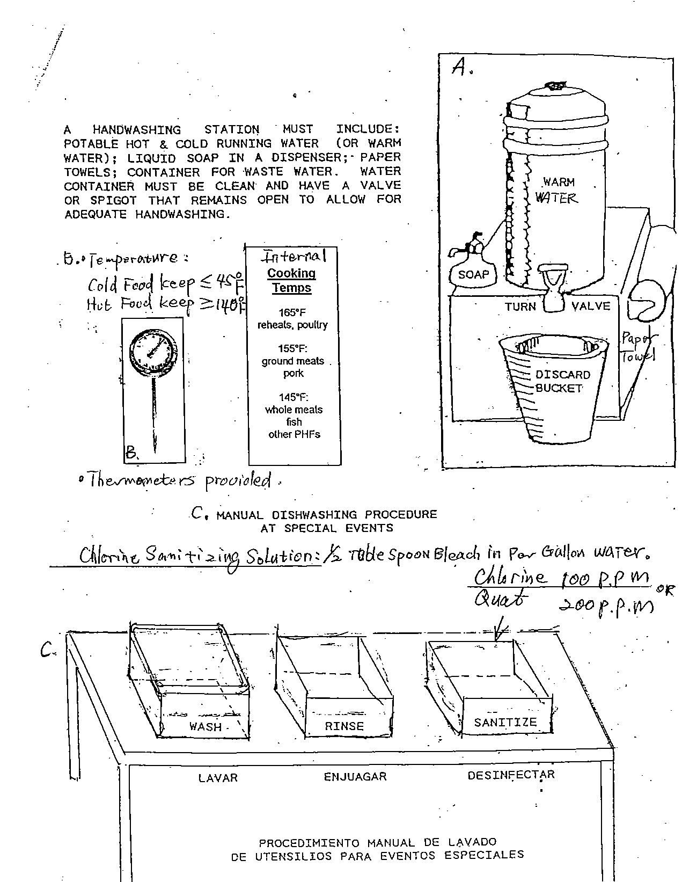

CITY OF HARTFORD
DEPARTMENT OF HEALTH AND HUMAN SERVICES
Environmental Health Division
131 Coventry Street
Hartford, Connecticut 06112
Telephone: (860) 757-4760 Fax: (860) 722-6677
www.hartford.gov

CREDIT/BANK CARD PAYMENT FORM
ACCEPTED CARD TYPE(S): DATE

CREDIT CARD NUMBER:

EXPIRATION DATE: _______________ CHARGE AMOUNT $ _________

BILLING ADDRESS: ______________________________________________________

CITY: ______________________________ STATE _________ ZIP __________________

NAME ON CARD: _________________________________________________________

AUTHORIZED SIGNATURE: _______________________________________________

Payment description:

FOR OFFICE USE ONLY
CARD TYPE:

Payment information received by: mail □ fax □ telephone □ in person □ e-mail □

DATE: CHARGE AMOUNT $

NAME ON CARD:

AUTHORIZED BY:

Payment description:

Please be advised that as of July 15, 2016 all debit and credit card transactions will include a 2.5% convenience fee for their use. Of special note, credit card information is handled with the highest degree of precaution to ensure that your personal information is protected. Once credit card transactions are processed the form is destroyed to prevent fraud or mishandling of information. A receipt for the transaction is available upon request. Thank you for your patronage.

