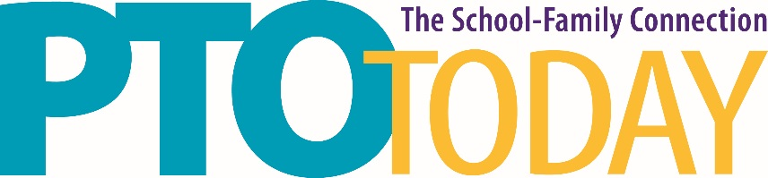

Nashville (Lebanon), TN March 1, 2017

Wilson County Fairgrounds

WiFi Connection

The Wilson County Fairgrounds offers FREE WiFi for their guests. There is no order form to fill out and no fee.

