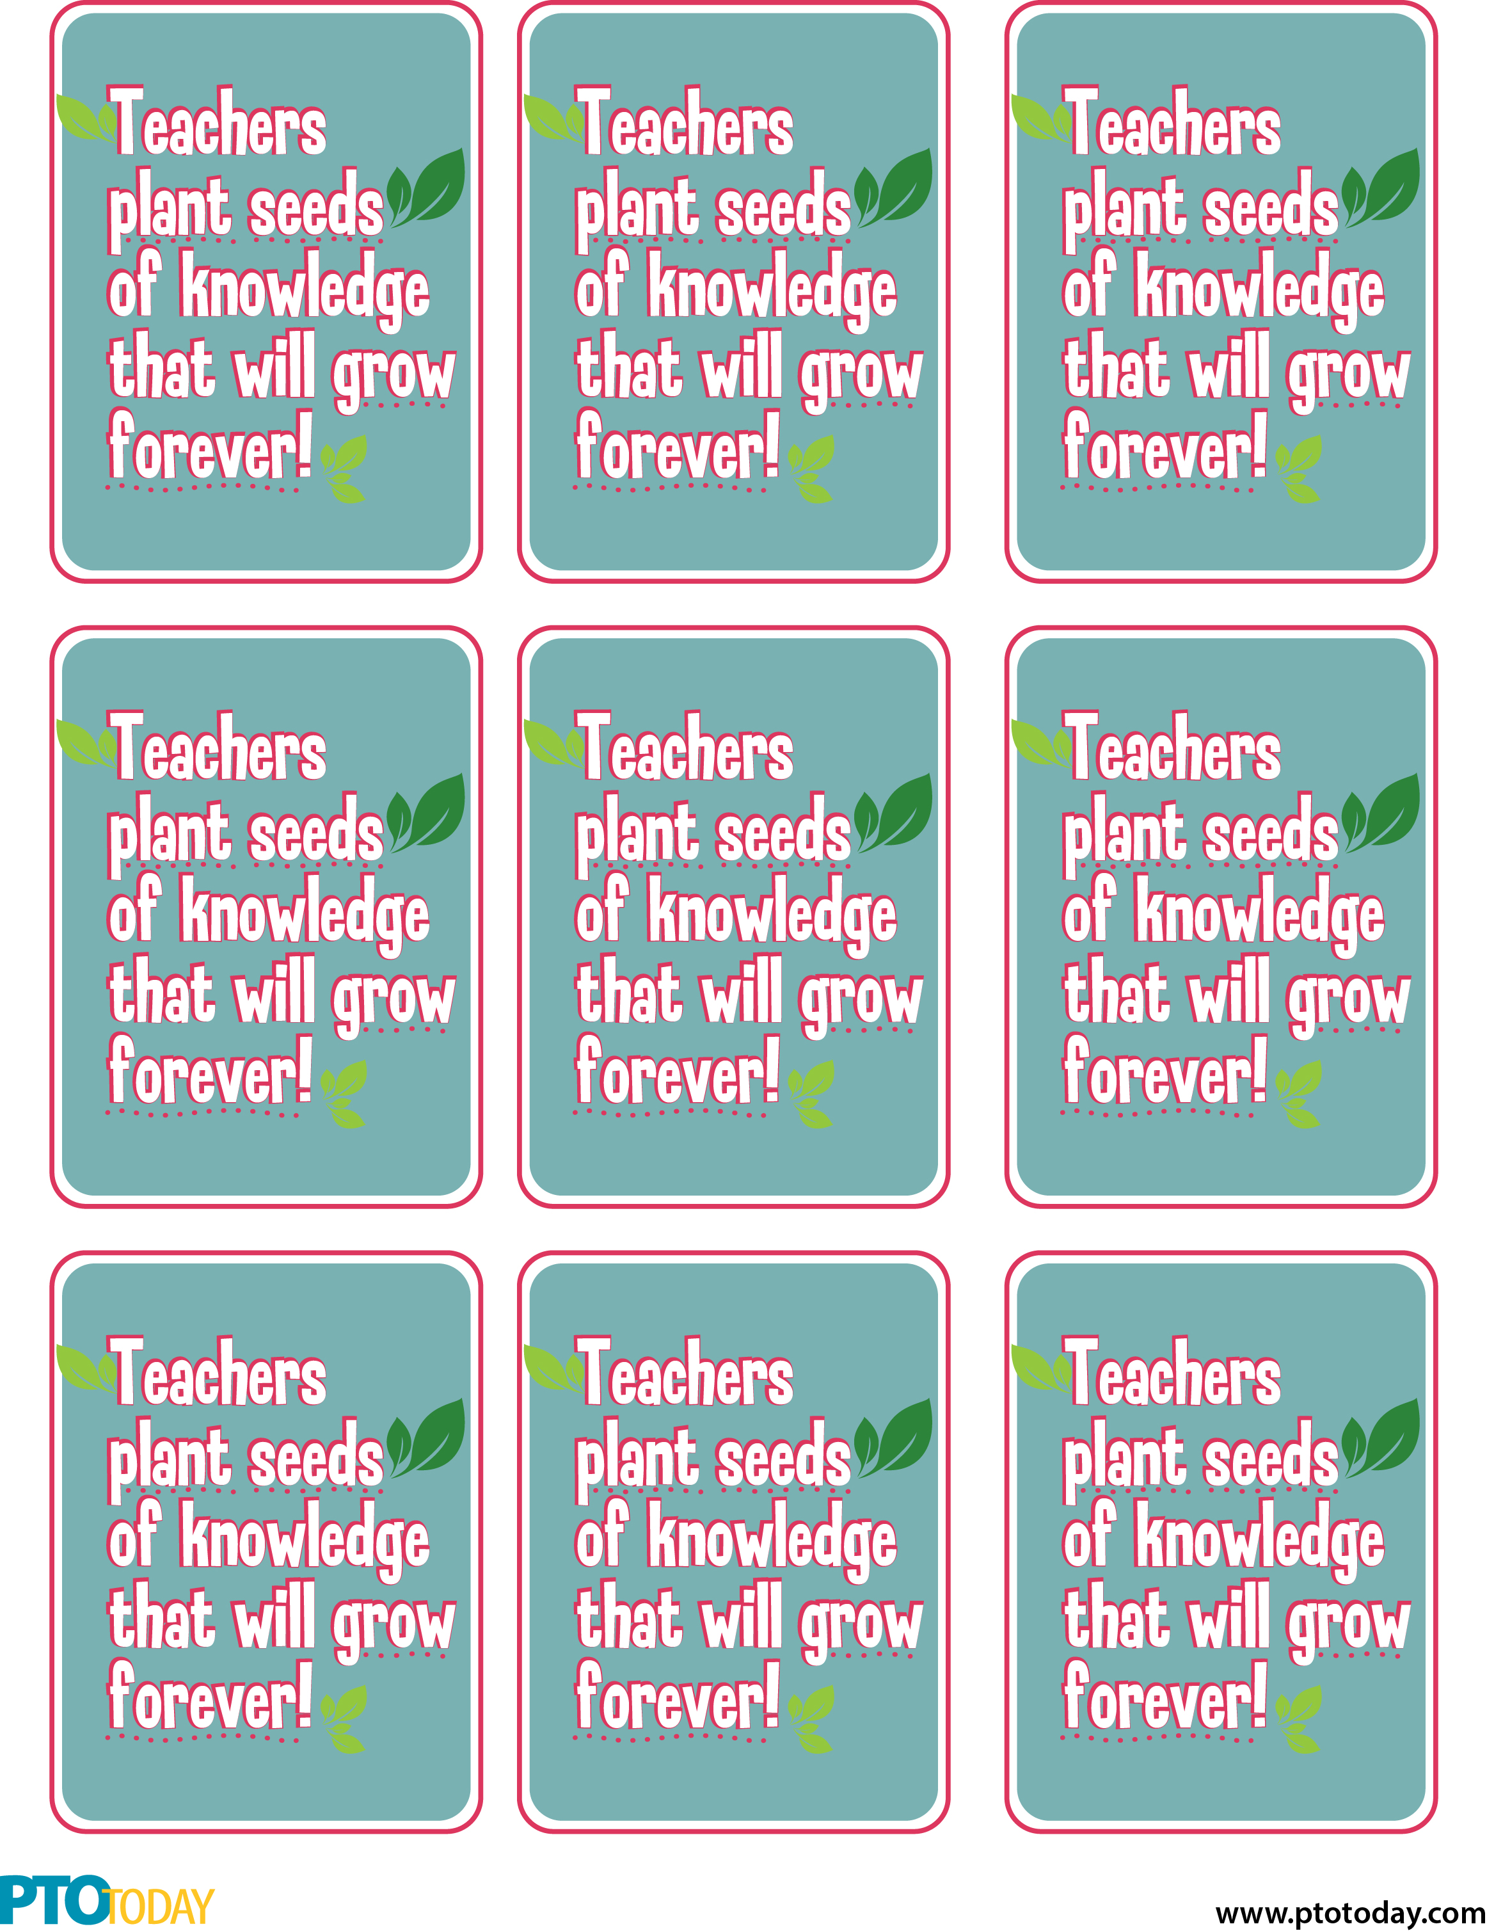

Teacher name here

Your name here

Teacher name here

Your name here

Teacher name here

Your name here

Teacher name here

Your name here

Teacher name here

Your name here

Teacher name here

Your name here

Teacher name here

Your name here

Teacher name here

Your name here

Your name here

Teacher name here