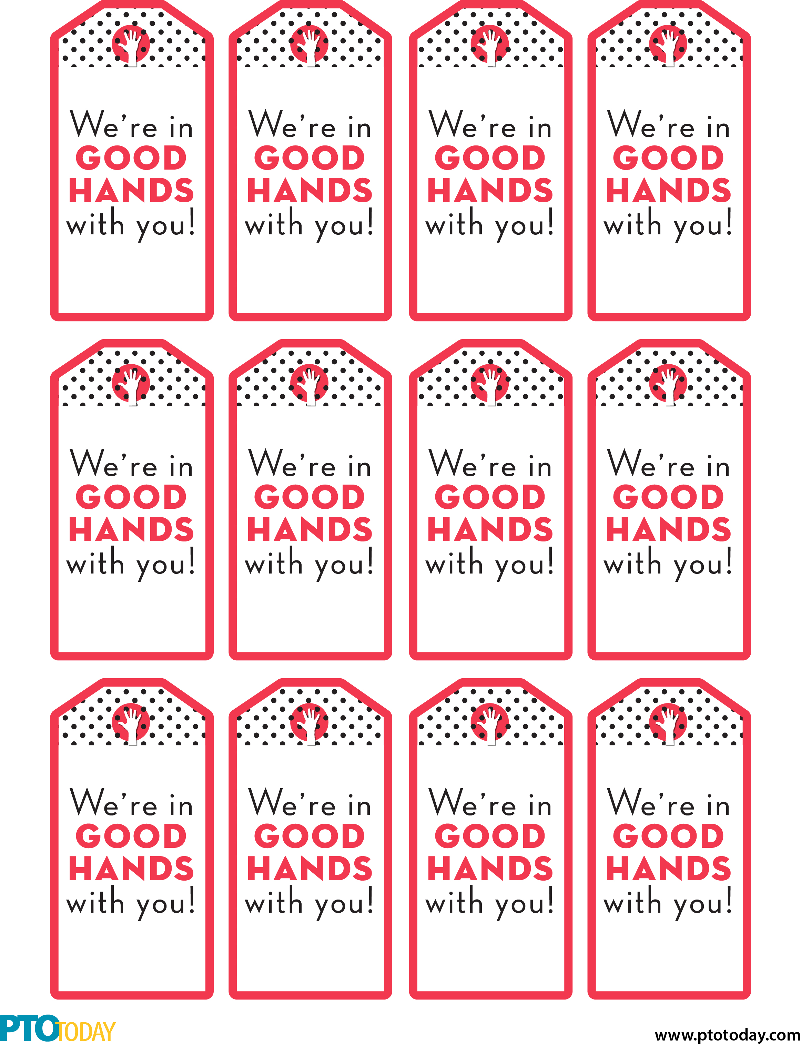

Your   
Name Here

Your   
Name Here

Your   
Name Here

Your   
Name Here

Your   
Name Here

Your   
Name Here

Your   
Name Here

Your   
Name Here

Your   
Name Here

Your   
Name Here

Your   
Name Here

Your   
Name Here