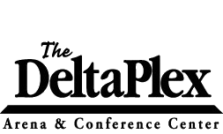

Exhibitor Rules and Information

- Load-in areas are for loading and unloading only. Once your vehicle and/or trailer has been unloaded, please move to the parking lot to organize your booth. Do not obstruct traffic.

- There are limited amounts of carts available to load-in/out your items. If not in use, they will be located in any of the load-in/out areas. If you use a cart please return to these areas when done.

- Vendors may ONLY load-in/out during hours provided by event promoter. Load-in doors will not open until these hours and promoter has approved.

- Once the show has opened, load-in and backstage areas, are for DeltaPlex staff only. If you need to leave the building or visit your vehicle, please do so through the main entrance.

- Please only use approved tape on any DeltaPlex equipment or the facility (including the floor or walls). Approved tapes include: gaff tape, painters tape, masking tape, or scotch tape. Please DO NOT use duct tape or other types of tape as it causes damage to the facility and equipment. Any damages caused will be billed at rates determined by building management.

- No helium balloons. If helium balloons are present and released for any reason within the facility, labor costs associated with the removal and/or any damages caused to HVAC systems will be billed accordingly.

