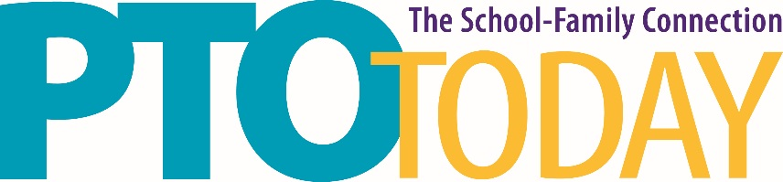

Akron, OH April 17, 2019

John S. Knight Center

Food Sampling Information

Temporary Food Service permits are not required at this location. However, safe food handling and service is required.

Additionally, if you are sampling food or beverage at the John S. Knight Center you must provide the following information via email to sphillips@ptotoday.com no later than April 5, 2019.
- Company name
- Name of contact person who will be sampling food/beverage
- Email address of contact person
- Food or Beverage item to be sampled

Please be aware that food samples must not be more than 2 oz. and beverage samples not more than 3 oz. Please refer to the Food Sampling Information in the Exhibitor Kit for more information.
Thank you in advance for your prompt attention to this important matter.

If you have any questions, please contact Susan Phillips at sphillips@ptotoday.com or 800-644-3561 ext 207.

Please be aware that failure to adhere to the policy and timelines may prohibit you from sampling food.

